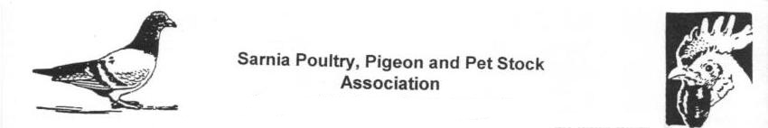
Sarnia Poultry, Pigeon & Pet Stock Association

***** SARNIA PIGEON SHOW *****

Saturday & Sunday - December 2nd & 3rd, 2017

At DeGroot's Nurseries, 1840 London Line, Sarnia

Specialty Breed Club Meets & an Open Show

*** Best Show Hall in Ontario ***
*** Best Judging Stations in Ontario ***
*** Best Judges in Ontario ***

Judges for this show:
All Breeds – Larry Gardner, Bellevue, Ohio
All Breeds – John Hoekstra, Wyoming, Ont.
All Breeds – Robert Stephens – Bobcaygeon, Ont.
American Show Racer Club – Dist 7 – Mike Carson, Scarborough, Ont.
Eastern Tumbler Club of Canada – Rick Rutledge, Brooklyn, Mich.

Specialty Clubs attending are:
- American Show Racer Club – District 7 (Mike Carson judging)
- Canadian Helmet Club (Robert Stephens judging)
- Canadian Indian Fantail Club (John Hoekstra judging)
- Canadian Jacobin Club
- Canadian Komorner Club
- Canadian Roller Club
- Canadian Show Tippler Club (Larry Gardner judging)
- Eastern Tumbler Club of Canada (Rick Rutledge judging)
- English Trumpeter Club of Canada
- Homer Club of Canada (Flying & Show Homers)
- Pouter & Cropper Combine Club (Larry Gardner judging)

- Open Show Entry Fees are $ 3.00 per bird.
- Specialty Club Entry Fees are set by your Specialty Club
- Deadline for entry forms & fees is Saturday, Nov. 18th, 2017
- Send entry forms and payment to Gary Parsons, 46 Vimy Cr., Sarnia, Ontario, N7S 1J6. Make cheques out to Sarnia Poultry & Pigeon Club.

- Birds can be cooped Friday afternoon & Saturday morning.
- Judging starts Saturday morning at 9:30 am.
- Final Line-up Judging to be complete Saturday at 5:30 pm.
- Prizes for all Specialty Club and all open Show Champions.
- Dinner Banquet Saturday evening after Judging is complete, cost is $20.00 per person.
- Elite Pigeon Auction Sunday morning with the Services of Dave McCormick, Professional Auctioneer.
- A seminar on Pigeon Health conducted by Dan McDermott, V.P. of ROPA-B, USA, manufacturers of Oregano Oil for Pigeons.
- Birds will be released Sunday morning.

For information and to book your Club for this show, contact:
Gary Parsons - garyhelmet@yahoo.ca - 519-336-5535
Tim Steadman - steadman.06@gmail.com - 519-845-0394

