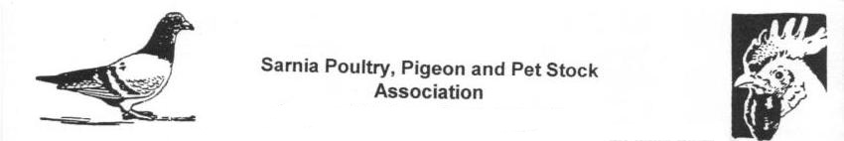
Sarnia Poultry, Pigeon & Pet Stock Association

First & Last Name:
Address, City, Province:
Phone, Email Address:

Breed | Variety/Colour | Old Male | Old Hen | Young Male | Young Hen | Total
Total number of Entries

Please include Payment with the entry form.
Please make cheques payable to Sarnia Poultry Pigeon & PSA.

