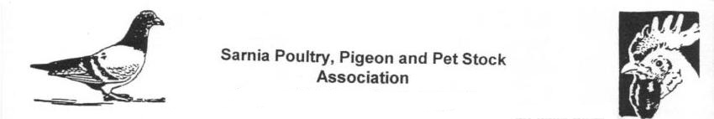
Sarnia Poultry, Pigeon & Pet Stock Association

IMPORTANT NOTICE - CANCELLATION - CPFA National Classic Show in Sarnia - Feb 4 & 5, 2017

Hi everyone. The Sarnia Club has decided to CANCEL the upcoming CPFA National Classic Show that was supposed to be held in Sarnia on Feb 4th & 5th, 2017.

Over half of the Specialty Clubs that were supposed to hold Specialty Club meets at this show have officially cancelled their meets, and the rest of the Specialty Clubs are reporting that half their expected participating members are not planning on showing.

Of course, all of this is due to the current pigeon sickness that is prevalent in Ontario and Quebec, which also happens to be the source of 90% of the entries for this Sarnia show! It is only in the last day or 2 becoming apparent that the current disease outbreak may be "PMV", at least it is better to know the enemy than to not know! But there are still a lot of undiagnosed lofts out there, and there are still losses being reported as of this day.

The Sarnia Club decided that it does not make sense to continue on with the show, with such a low expected turnout of fanciers and birds. We feel that it is the best thing to do as far as the hobby is concerned, we would rather be "part of the solution" rather than be "part of the problem", we do not want to hold a show where it would be possible to have more pigeons / lofts infected with the current sickness.

The Sarnia Poultry Pigeon and Pet Stock Association apologizes for any inconveniences caused by the cancellation of this show, and all show entry fees will be refunded.

The SPP&PSA 102nd Annual Poultry Show:

Please Note: that the regular annual Poultry Show scheduled for Saturday Feb 11, 2017 sponsored by the Sarnia Poultry Pigeon and Pet Stock Association is not cancelled, it will still go on as scheduled. Entries will be accepted for all varieties of chickens and waterfowl as usual, but not for pigeons for this year. The show will be held at DeGroot's nurseries, also as previously scheduled.

