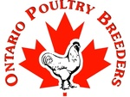
26Th Annual Show
On Behalf of the Organizers of the Ontario Poultry Breeders, we wish to welcome you to our 2019 edition of Canada’s Premier Poultry Show.
October 19& 20 ,2019 @ The West Niagara Fairgrounds Grassie,Ontario
Judges for the Show
Anthony Ashely SC, Steven Beaty NM, Lewis Cunningham OH, Jamie Matts NY
and handling our Junior Show and Showmanship is Tylor Murray OH

Classes for all recognized and non recognized breeds and varieties of
Large Fowl, Bantam,Turkeys ,Guineas, Ducks and Geese.
Entry fees are $3 per bird, Trios $9, Double coops (if requested for Large Fowl only $6) Exhibitors fee of $5 for Open show exhibitors (Juniors showing junior show are exempt) Juniors are 6-18 years of age (APA Rule)
We are honoured to announce our 2019 Show Sponsors
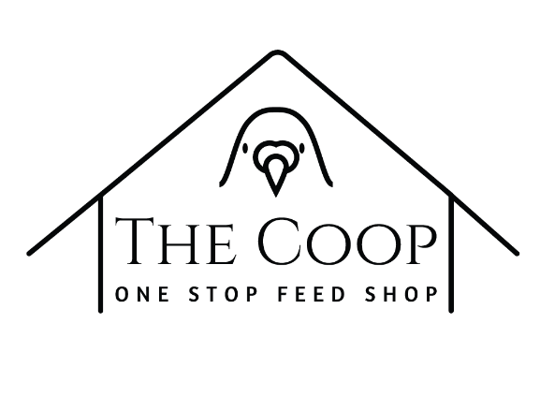

Feather Elite /The Coop will be on hand at the show with a full line of medications, vaccines, feeds, bird carriers and other supplies for all your birds needs. Feather Elite also offers import / quarantine services from Europe. For more information or to pre-order your supplies contact Lia or Ryan at featherselite@gmail.com 416-990-0187 or Feathers Elite on Facebook or featherselitepigeonauction.com

Junior show & Showmanship
Our Junior show has become a popular event among our budding future fanciers. We offer classes for all recognized and Non recognized breeders of varieties of poultry. Juniors are between 6 and 18, Juniors are encouraged to show both in junior and open show but must have separate birds for each open and junior shows. Entry fees are the same as the open show. Please state on the entry form if you are a junior and state what birds you want shown in the open section of the show.
Showmanship:
Once again, we will be holding a Junior showmanship competition. This is a great opportunity for children to learn. This competition will take place right after the Junior show judging is complete. We will announce the procedure at that time
Awards
The Following awards will be offered by Ontario Poultry Breeders
A large Rosette will be awarded to Champions and a smaller Rosette will be awarded to the Reserves in the Following Classifications
Large Fowl:
American, Asiatic, Mediterranean, Continental, English, Any Other Standard Breed.
Bantam:
Modern, Game (OE & American), Single Comb Clean Leg, Rose Comb Clean Leg, Feather Leg, Any Other Comb Clean Leg.
Duck: Bantam, Light, Medium, Heavy
Goose: Light, Medium, Heavy
Turkey & Guinea
Champion and Reserve of the following will be awarded Rosettes
Large Fowl, Bantam, Duck, Goose
Champion and Reserve Champion of the show will be awarded a unique trophy
Trio competition will be as follows $75 for Best $50 for Reserve and $25 of 3rd Best provided there are 10 or more trios shown. All trios show against one another

2019 Meets
American Poultry Association District Meet
American Bantam Association Provincial Meet
Cochins International Western National Meet
Modern Game Bantam Club of America District Meet
American Brahma Club District Meet
International Waterfowl Breeders Association District Meet
Old English Game Bantam Club Special Meet
Rhode Island Red Club Special Meet
Plymouth Rock Club Special Meet
Wyandotte Breeders Special Meet
The Domestic Waterfowl Club of Great Britain will be exchanging Rosettes with us as a gesture of good will between nations in the name of waterfowl. Awards from the British club will be handed out in addition to our regular waterfowl awards. We thank the UK club for this gesture.
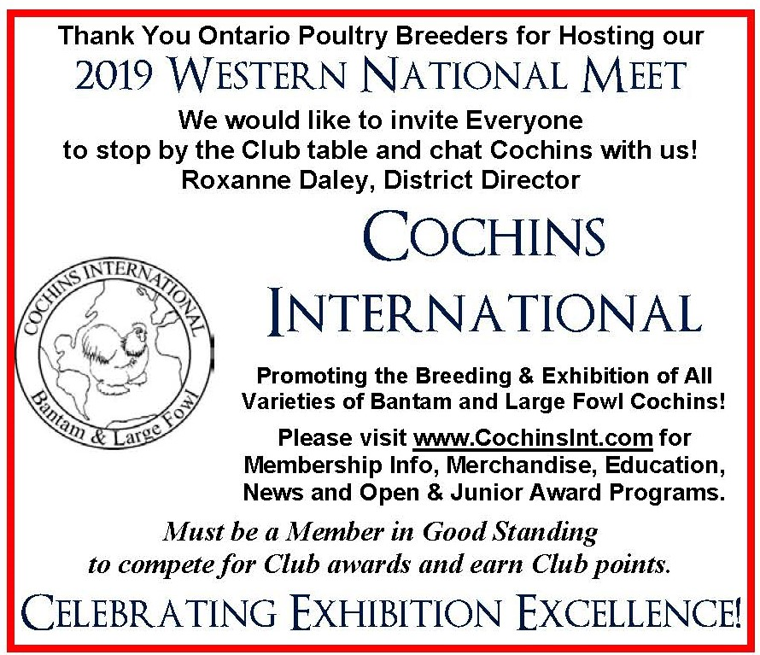
Awards offered by Cochins International and Individuals in honour of the breed
Junior Awards:
Best Jr Cochin (Bantam and LF competing) $50 don by Beamers Poultry
Reserve Jr Cochin (Bantam and LF competing) $25 don by Roxanne Daley
Open Show Awards
Champion Cochin of show $25 Reserve Cochin of show $25
Best Large Fowl Cochin $50 Reserve Large Fowl Cochin $25
Best AOV Large Fowl $25 Reserve AOV Large Fowl $25
Best Large Fowl Cochin Trio $25 Reserve Large Fowl Cochin Trio $25
Best Buff Large Fowl Cochin $100 don By Linda Henderson & Dave Stuart
Best Bantam Cochin $50 Reserve Bantam Cochin $ 25
Best AOV Cochin Bantam $25 Reserve AOV Bantam Cochin $25
Best Bantam Cochin Trio $25 Reserve Bantam Cochin Trio $25
Cochins International would like to thank the following individuals for donating awards

Linda Henderson & Dave Stuart Beamers Poultry
Jeff Wilbur Ron Smith
Lisa Krick Paul Monteith
Brad Painter Roxanne Daley
Jeremy Ludyka Troy Laroche
OPB Will be awarding $50 to Champion Large and Bantam Cochin

Individual Awards
Champion Large Fowl $100 sponsored by Jean Paul Cousineau

Reserve Champion Large Fowl $50 donated by a Friend of the hobby- in Memory of George Houtby

Champion Bantam Chicken Award $100 Cash Donated by a Friend of the hobby- in Memory of George Houtby

Reserve Champion Bantam $50 Donated by a Friend of the Hobby - in Memory of George Houtby

Champion Overall Waterfowl “The Leigh Harrington Memorial Award “Sponsored by Don Harrington in memory of his Grandfather

Plaques for Best White Call, Grey Call, AOC Call and Best Indie duck will be presented donated by Don Harrington

More specials will be posted at the show. We would like to say thanks to our sponsors for the kind donations.

OPB is not responsible for any awards offered by individual or clubs.

OPB 100 bird challenge
OPB will pay 1 dollar per bird winner takes all for any breed that has 100 or more birds competing. An example of this challenge is as follows, if there are 111 wyandotte bantams shown there will be $111 Awarded to the best of breed by OPB. If there are 99 Large Fowl Wyandottes shown there would not be a cash award by OPB. We challenge all to bring out your best and bring out your numbers.

Sales Area (Traders Row)
Sales cages will be offered for use to sell your extra stock on a first come first serve basis. Cages should be booked with your entries. Cages are $5 per Large Fowl hole. Please limit birds per hole to 3 Large Chickens or large ducks, 8 Bantam chickens or Bantam Ducks. Turkeys and geese will not have cages provided in the sales area, but if space is available after the show has been set up areas will be rented with owners providing their own cages (Turkeys and geese only) Contact Troy for details. Please no outside sales as this is not permitted by our rental agreement with the facility. Please keep the sales area clean and be respectful of the birds. Sales area is open to all to buy but only for exhibitors to sell from, this will be strictly policed.

Donated Quality Birds and items from across North America
We would like to thank all our generous donators for the below list of donated birds and items.The birds are from some of the top breeders in North America and are a great chance to get good stock not easily obtained elsewhere. Proceeds from this auction are split with the Niagara Feather Fanciers club as they help us put on this great event. These funds aid us in putting on the show year in and year out. The auction is a silent auction with a soft closing with the last two bidders able to battle it out until the lot is sold. Details will be posted in the show hall. This auction will take place in the show hall on Saturday with it finalizing approximately 2:30 PM Saturday October 19,2019

1 Pair of Millie Fleur Duccles Bantams-Donated by Don Harrington Ontario
1 Pair of White Rock Bantams-Donated by Jonathan Patterson Indiana
1 Pair of Black Australorps Large Fowl-donated by Dan Castle Connecticut
1 Pair of white Cochins Bantams- Donated by M&M Poultry Matt Lhamon & Mike Sayre Ohio
1 Pair of SC Rhode Island Red Bantams- Donated by Dennis Meyers Ohio
1 Pair of White Old English Bantams -Donated by Cheryl Barnaba & Cesar Botelho Connecticut
1 Pair of Bantam Ducks (To be determined) Donated by Art Lungren New York
1 Pair of White Laced Red Cornish Large Fowl -Donated by Danny & Norma Padgett Florida

2 Whiskey Bottle Lamps -Donated by M&M Poultry Ohio

All birds mentioned above subject to change based on availability and circumstances beyond our control. OPB reserve the right to make changes to accommodate any birds not available at sale time.

Hotel Information
Our host hotel is the Casablanca Winery Inn 4 Windward Drive Grimsby Ontario. Our block of rooms has sold out, but some rooms may be available outside of our block. Do not delay as it is fall colour season and rooms will not last. Other hotels in the area may have availability. Contact the Casablanca Inn at 877-446-5746
OPB Poultry Social
Saturday night Poultry Social is held in the lobby/bar area of the bar at the Casablanca Winery Inn (Bogeys Grill) We invite all exhibitors and friends of the fancy to join us for some fun and conversation. Cash Bar and Food is available.

SF Apparel
SF Apparel will be on hand again this year and they are the official retailer of OPB souvenirs. They will have ball caps, shirts, show aprons as well as other items of interest on hand to purchase. They also offer a full line of custom embroidery services for provided by your garments on site at the show. Pre-orders are encouraged and in some cases required. Contact them for more information or for pricing contact them at , facebook.com/sfapparel.ca or contact Jacob sfapparel2018@outlook.com 647-999-9084

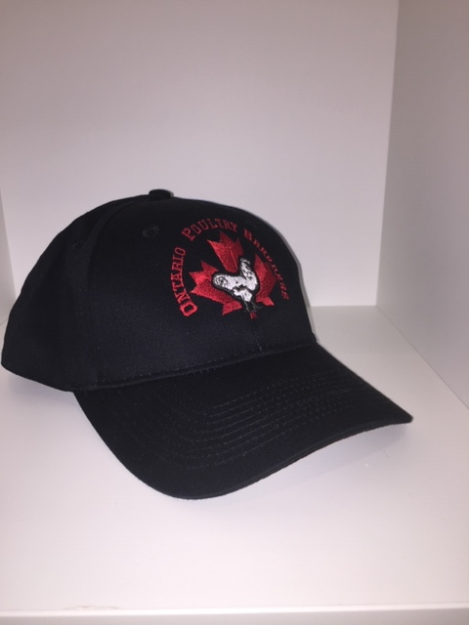

Rules
- Entry deadline is Tuesday October 1,2019 (12 midnight) or post marked by October 1.2019. Entries must be accompanied with payment for entries or they will not be processed. Acceptable payment, cheque, Money Order or E Transfer. USA exhibitors may us PayPal for payment (USA exhibitors only) USA Checks are ok as well.
Entries to be send to Troy Laroche 12187 8th Line Georgetown Ontario L7G 4S4 or emailed to troylaroche88@hotmail.com (e-transfers sent to this email address as well).Classes for all recognized and non recognized breeds and varieties of Large Fowl, Bantams , Ducks ,Geese , Turkeys and Guinea Fowl.

- Entry fees are $3 per bird, trios are $9 double coops for Large Fowl (Optional) are available at $6
Exhibitor fee is $5 to be included in payment. Juniors who are showing in the junior show are exempt from this fee (6-18 years of age)

- Juniors can and are encouraged to show in both the open and Junior show but must have separate birds for both sections. You can not show the same bird in Open as they do junior.
- Junior Showmanship will take place shortly after the Junior show judging. Showmanship is a learning and knowledge competition and is great event for children to take part in. Awards will be handed out to the top two winners in each divisional group.
- Runner ducks will be judged in the ring at the commencement of judging ( 9 am) in a designated area. This will be announced right after opening announcements.
- Isles will be roped off when judging is taking place. We ask that all exhibitors and public be respectful of the judges and clerks as not to interfere with the judging process. Judges will be available after judging is complete to go over classes and answer questions.
- The show hall will be open at 5 PM-8PM October 18,2019 for cooping in. Please be respectful of these times with no late arrivals please. The building will reopen at 7 AM October 19,2019 with all birds to be cooped in by 9 AM with judging to commence shortly there after. All birds must remain in their coops until Sunday October 20,2019 after the awards are handed out. Approximately 10:30 AM. Champions will be picked at 9 AM Sunday October 20,2019.
- Ontario Poultry Breeders will be practicing biosecurity procedures as recommended by the Ontario Ministry of Agriculture and Rural Affairs. We ask that you review these recommendations prior to the show. These rules can be found on the OMAFRA Website at omafra.gov.on.ca under poultry (biosecurity for poultry shows) We ask your assistance in our quest to protect all our birds from disease. We will be inspecting continually through out the show for any issues regarding bird health.
Hotel Room Raffle
We have a few more raffle numbers available for our annual draw for a free room for the show weekend (two nights ) at the Casablanca Winery Inn (room only not incidentals) If you already have a room reserved you can opt to take the cash instead $250 value .Tickets are $10 each . We will be drawing a number using a random number generator as soon as all the numbers have been purchased. For more information or to purchase numbers contact John Beamer at johnbeamer77@gmail.com or 289-214-1731

Final Note:
Ontario Poultry Breeders strive to provide all exhibitors and visitors to our show a positive experience and warm atmosphere to exhibit and socialize with our birds. We appreciate that we all have different opinions in life. We ask that everyone be respectful to all fellow exhibitors, judges and visitors of our show. Any and all hand-out materials must be approved by the organizers prior to being handed out…NO EXCEPTIONS! Any issues not covered by the show rules of the APA and the ABA will be dealt with at the discretion of the show committee. Enjoy the show and have fun. It is what the poultry hobby is all about. Remember smiles are contagious.
OPB Show Committee

