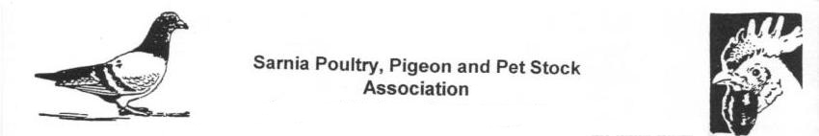
Sarnia Poultry, Pigeon & Pet Stock Association

*** 102nd Anniversary Pigeon & Poultry Show ***
Saturday - February 11th, 2017
at Degroot’s Nurseries, 1840 London Line, Sarnia

Junior and Senior Classes available for Pigeons and Poultry

All Junior Exhibitor entries (18 yrs & under, the Junior exhibitor must be in attendance) are $ 2.00 each, Senior Exhibitor entries are $ 3.00 each.
Entries and payment must be received by Jan 23, 2017 (make cheques payable to “Sarnia Poultry Pigeon & Pet Stock Association” or "SPP&PSA")

For more information, entry forms, and to send your entries, contact:
- Sue Cristante, 6018 Blackwell Sideroad, Sarnia, Ont., N7T 7H2, 519-541-1768 or suecristante@rocketmail.com

Show Hall doors open Friday afternoon and again at 8:00 a.m. Saturday morning.

Judging starts at 9:30 a.m. Saturday morning (or sooner).

All birds stay cooped up until the show ends at 5:00 p.m. (or sooner).

There are no "For Sale" cages, if you want to sell some birds, enter them in the show.

Sick or extremely poor condition birds will be removed from the show.

The Pigeon Judge is Charlie Power from Petersburg, Ontario
The Poultry Judge is Michael Becker from Dashwood, Ontario

APA and ABA Sanctioned Poultry Show

Prizes will be Trophies, Rossettes, Ribbons and Certificates

